

NAME : DARSHNEEPRIYA SANDRA SIGARAN

LOGIN ID : darshneepriya@oasis-portal.com

COURSE TITLE : ESSENTIALS OF ACCOUNTING FUNDAMENTALS

SUBJECT CODE : BHM03

SUBMITTED DATE : 14 AUGUST 2017

1

TABLE OF CONTENTS

|  |  |  |
| --- | --- | --- |
| NO | DETAILS | PAGE |
| 1 | EXECUTIVE SUMMARY | 2 |
| 2 | INTRODUCTION | 3-4 |
| 3 | ASSIGNMENT QUESTION |  |
|  | PART 1 | 5-13 |
|  | PART 2 | 14-15 |
|  | PART 3 | 16-22 |
|  | PART 4 | 23-27 |
| 4 | CONCLUSION | 28 |
| 5 | REFERENCES | 29 |
| 6 | APPENDIX | 30 |

EXECUTIVE SUMMARY

In this module, I will cover the topic of Accounting Fundamental and will show the concept of Accounting Fundamentals. In the first part of question, we can see the introduction of Accounting Fundamentals and its importance and roles of accounting. Besides that, i would like to share some information about history of accounting In second part of question, I will describe about the differences between account payable and receivable. Furthermore, I will describe about the double entry accounting and some additional notes about accounting cycle. While, in third part of question i would talk about a company's profit and balance sheet with some simple examples. Last but not least, i will explain about the bank reconciling statement.

2

INTRODUCTION :

Accounting is a system meant for measuring business activities, processing of information into reports and making the findings available to decision makers. The documents which communicate these findings about the performance of an organisation in monetary terms are called financial statements.

Usually, accounting is understood as the Language of Business. However, a business may have a lot of aspects which may not be of financial nature. As such, a better way to understand accounting could be to call it The Language of Financial Decisions. The better the understanding of the language, the better is the management of financial aspects of living. Many aspects of our lives are based on accounting, personal financial planning, investment, income tax, loans and etc. We have different roles to perform in life the role of a student, a manager, of a n investor, etc. The knowledge of accounting is an added advantage in performing different roles. However, we shall limit our scope of discussion to a business organisation and the various financial aspects of such an organisation.

When we focus our thoughts on a business organisation, many question ( is our business profitable, should a new product line be introduced are the sales sufficient, etc ) strike our mind. To answer questions of such nature, we need to have information generated through the accounting process. The people who take policy decision and frame business plans use such information.

All business organisations work in an ever changing dynamic environment. Any new programme of the organisation or of its competitor will affect the business. Accounting serves as an effective tool for measuring the financial pulse rate of the company. It is a continuous cycle of measurement of result and reporting of result to decision makers. Just like arithmetic is a procedural element of mathematics, bookkeeping is the procedural element of accounting.

Accounting plays a vital role in facilitating all forms of economic activity in the private, public and non profit sectors. Business owners and managers in both large and small companies use accounting information to gauge how their business is doing. Non profits track the cash flow and income needed to fuel their organizations mission.

Government entities use accounting information operationally as well as to track tax revenues that may be due to them from other government entities and tax payers.

3

The American Accounting Association offers this definition : ' The process of identifying, measuring and communicating economic information to permit informed judgements and decisions by users of the information.' In other words, accounting is the basis of all decision making.

Figure 1 shows how an accounting system operate in business and how the flow of information occurs.

**People make decision**

**Business transactions occurs**

**Accountants prepare reports to show the results of business operations**

Figure 1 : The accounting System

4

ASSIGNMENT QUESTIONS

QUESTION 1: In a brief but comprehensive response, define the role of accounting?

MEANING OF ACCOUNTING

Bookkeeping is the process of classifying, recording and summarizing business transactions. Accounting is the systematic and comprehensive recording of financial transactions pertaining to a business, and it also refers to the process of classifying, recording, and summarizing business transactions in monetary units and interpreting the financial data of a business in order to assist stake holders in making decisions. Accounting is a fundamental of business flowness in a field where by involving payer and receiver in a term by performance.

Accounting involves the following four phases :

a) Classifying : - Accounting data from business documents are arranged and categorized. Examples: receipts, invoices and cash bills.

b) Recording : - Transactions are recorded in day books and ledgers.

c) Summarizing : - Accounting data for a particular period is summarized in the form of financial statements. Examples of financial statements are Trading Accounts, Profit and Loss Accounts and Statement of Financial Positions.

d) Analysing and Interpreting : - Financial statements are analysed and the result of the analysis is used as a guide to make a decisions.

Classifying

Bookkeeping → Recording

Summarizing → Accounting

Analysing

Interpreting

Figure 1.1 Activities involved in bookkeeping and the accounting process

5

There are two types of accounting : - a) **Financial Accounting**

- b) **Management Accounting**

a) **Financial Accounting :**

1. Provides accounting information that is designed to be used by external users.

2. The information is usually prepared in the form of financial statements.

3. The information is more concerned with the financial position, performance and changes in financial position of a business.

4. A report generated based on the financial accounting report neither interprets nor advises ( in detail ) on the financial situation of a business.

5. The financial accounting report, instead, creates a public record of a business specifically, it records the past financial performance of the business. This will give external users a clear picture of the business financial status.

6. This will have an impact on decisions, such as the decision to buy/sell a business shares by shareholders, an imposition of business tax by government authorities and loan decisions to businesses by financial institutions.

b) **Management accounting** :

1. Provides accounting information that is designed to be used by internal users or those within the business itself.

2. The information is usually prepared in the form of customized designed reports.

3. The information gained will be used by decision makers in their daily business operations or for investment purposes in the business.

4. This will have an impact on decisions, such as the decision to open a new branch of a business by the manager or director of the business, the selling price of a product, the discount rate of goods sold/purchased and whether to buy goods in credit or cash.

5. The bottom line is the information is needed in the business for responsible decision making that might lead to maximum profit, efficient conduct and valuable business operations.

6

HISTORY OF ACCOUNTING

The history of accounting or accountancy is the thousands of years old and can be traced to ancient civilizations. The early development of accounting dates back to ancient Mesopotamia and is closely related to developments in writing, counting, and money and early auditing systems by the ancient Egyptians and Babylonians. By the time of the Emperor Edrian Henio, the Roman government had access to detailed financial information. In India Chanakya wrote a manuscripts similar to a financial management book, during the period of the Mauryan Empire. His book " Arthashasthra" contains few detailed aspects of maintaining books of accounts for a Sovereign state.

The Italian Luca Pacioli, recognized as The Father of accounting and bookkeeping was the first person to publish a work on double-entry bookkeeping and introduced the field in Italy. Accounting History is a specialist, international peer-reviewed journal that encourages critical and interpretative historical research on the nature roles, uses, and impacts of accounting and provides a forum for the publication of high quality manuscripts on the historical development of accounting across all organisations forms.

7

DOUBLE ENTRY

Introduction : - The double entry system is the basic of an accounting recording system. An in depth understanding of this system is needed in order to maintain a correct, organized and accurate bookkeeping record. Double entry accounting is based on the fact that every financial transaction has equal and opposite effects in at least two different accounts it is used to satisfy the equation : Asset= Liabilities + Equity, in which each entry is recorded to maintain the relationship. This equation system explained and playing a big role in business profit appearance on a credit balance sheet in account sheet. Double entry accounting is based on a simple concept each party in a business transaction will receive something and give something in return. In bookkeeping terms, what is received is a debit and what is given is credit. The "T" account represent of a scale or balance.

Dr Assets/Expenses/Drawings Account Cr

Balance b/d xx

Increase in value xx Decrease in value xx

Dr Liabilities/Capital/Revenue Account Cr

Balance b/d xx

Decrease in value xx Increase in value xx

8

ACCOUNTING CYCLE

- An accounting cycle is the process of recording business transactions. This cycle involves several stages over a particular period of time. An accounting cycle shows the steps to collect and record business information systematically so that the financial reports or statements can be presented to the management and analysed.

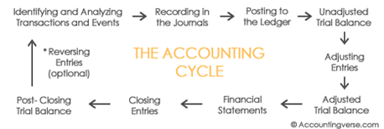

Figure 1.2 The accounting cycle

1. Identifying and Analyzing Business Transactions

- The accounting process starts with identifying and analyzing business transactions and events. Not all transactions and events are entered into the accounting system. Only those that pertain to the business entity are included in the process. The first step included the preparation of business documents or source documents. Example : Invoice, Receipts and Debit notes or Credit notes.

2. Recording in the Journals

A journal is a book – paper or electronic – in which transactions are recorded. Business transactions are recorded using the double-entry bookkeeping system. They are recorded in journal entries containing *at least* two accounts (one debited and one credited).

To simplify the recording process, special journals are often used for transactions that recur frequently such as sales, purchases, cash receipts, and cash disbursements. A general journal is used to record those that cannot be entered in the special books.

9

3. Posting to the Ledger

-Also known as *Books of Final Entry*, the ledger is a collection of accounts that shows the changes made to each account as a result of past transactions, and their current balances.

After the posting all transactions to the ledger, the balances of each account can now be determined. Over the accounting period, debits and credits accumulate in each account as they are transferred here from the journal.

4. Unadjusted Trial Balance

-A trial balance is prepared to test the equality of the debits and credits. All account balances are extracted from the ledger and arranged in one report. Afterwards, all debit balances are added. All credit balances are also added. Total debits should be equal to total credits.

5. Adjusting Entries

-Adjusting entries are prepared as an application of the *accrual basis of accounting*. At the end of the accounting period, some expenses may have been incurred but not yet recorded in the journals. Some income may have been earned but not entered in the books.

Adjusting entries are prepared to update the accounts before they are summarized in the financial statements.

6. Adjusted Trial Balance

-An *adjusted trial balance* may be prepared after adjusting entries are made and before the financial statements are prepared. This is to test if the debits are equal to credits after adjusting entries are made.

7. Financial Statements

-When the accounts are already up-to-date and equality between the debits and credits have been tested, the financial statements can now be prepared. The financial statements are the end-products of an accounting system.

10

8. Closing Entries

-Temporary or nominal accounts, i.e. income statement accounts, are closed to prepare the system for the next accounting period. Temporary accounts include *income, expense, and withdrawal* accounts. These items are measured periodically.

9. Post-Closing Trial Balance

-In the accounting cycle, the last step is to prepare a post-closing trial balance. It is prepared to test the equality of debits and credits after closing entries are made. Since temporary accounts are already closed at this point, the post-closing trial balance contains real accounts *only*.

\*10. Reversing Entries: Optional step at the *beginning* of the new accounting period

-Reversing entries are optional. They are prepared at the beginning of the new accounting period to facilitate a smoother and more consistent recording process.

11

ROLE OF ACCOUNTING

**1. Owners and Managers**

In summarizing the outcomes of a company’s financial activities over a specified period of time, financial statements are, in effect, report cards for owners and managers. They show, for example, whether the company did or didn’t make a profit and furnish other information about the firm’s financial condition. They also provide information that managers and owners can use in order to take corrective action.

**2.Investors and Creditors**

If you loaned money to a friend to start a business, wouldn’t you want to know how the business was doing? Investors and creditors furnish the money that a company needs to operate, and not surprisingly, they feel the same way. Because they know that it’s impossible to make smart investment and loan decisions without accurate reports on an organization’s financial health, they study financial statements to assess a company’s performance and to make decisions about continued investment.

**3.Government Agencies**

Businesses are required to furnish financial information to a number of government agencies. Publicly owned companies, for example—the ones whose shares are traded on a stock exchange—must provide annual financial reports to the Securities and Exchange Commission (SEC), a federal agency that regulates stock trades. Companies must also provide financial information to local, state, and federal taxing agencies, including the Internal Revenue Service.

**4. Other User**

A number of other external users have an interest in a company’s financial statements. Suppliers, for example, need to know if the company to which they sell their goods is having trouble paying its bills or may even be at risk of going under. Employees and labor unions are interested because salaries and other forms of compensation are dependent on an employer’s performance.

12

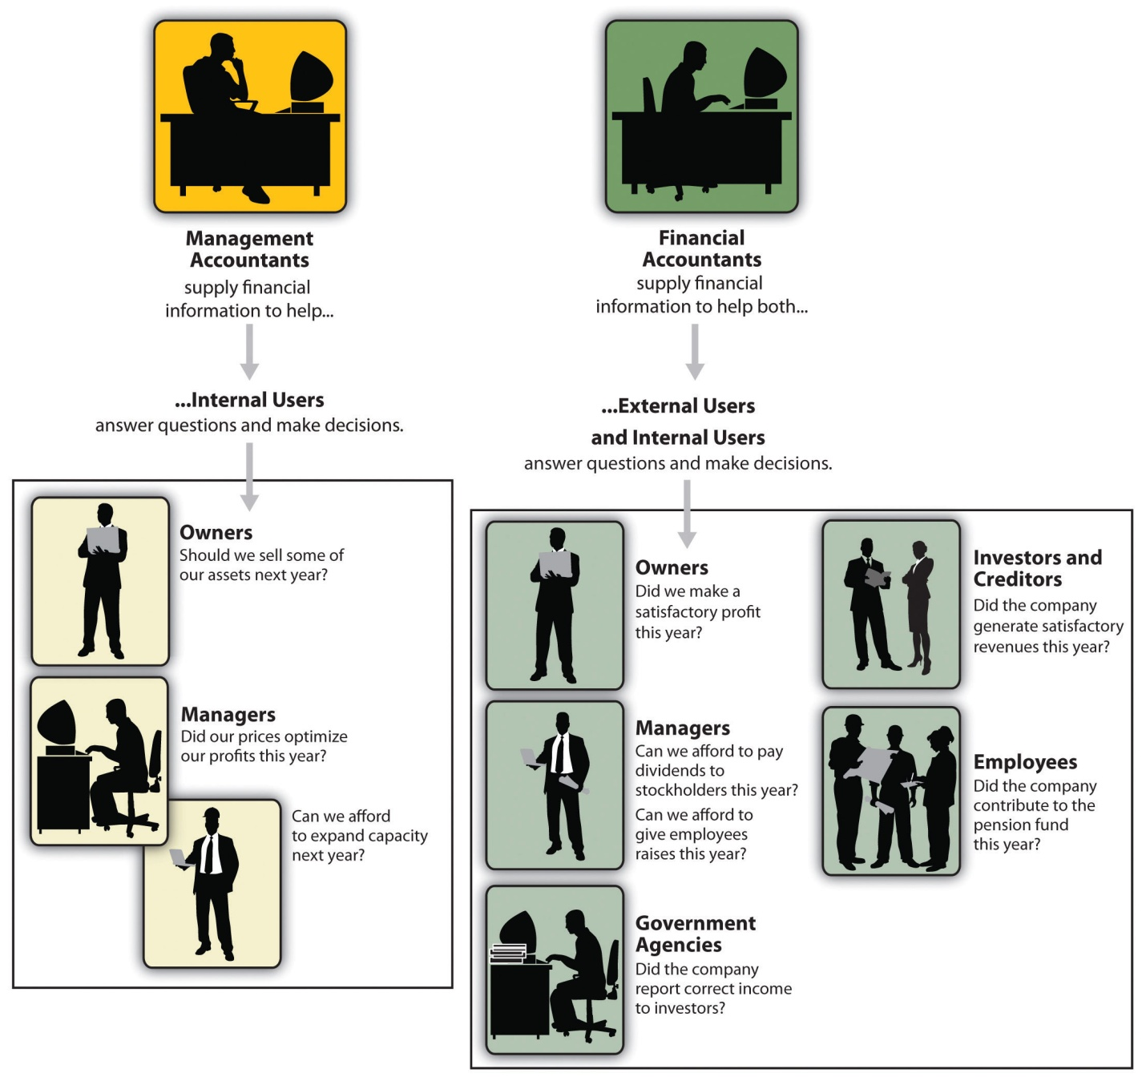

Figure 1.3 Role of accounting

13

QUESTION 2 : What is the difference between accounts payable and accounts receivable?

-**Accounts payable** are amounts a company owes because it purchased goods or services on credit from a supplier or vendor. **Accounts receivable** are amounts a company has a right to collect because it sold goods or services on credit to a customer. **Accounts payable** are liabilities. **Accounts receivable** are assets.

MEANING

**a) Accounts Payable management** – It’s a process of maintaining a record known as AP sub- ledger (balance sheet of company) to keep track on money that is owed by a business to its suppliers. It is different from notes on payable liabilities, which are debts formally created by legal instrument documents. The amount is firstly recorded at the time when the order is been vouchered for the payment. The term vouchered refers that invoice is been approved by the company for manual payment. Other than the approval, the order needs to be recorded on the AP general ledger in the category of trade payables, for the purchase of goods or for availing the services.

**b ) Accounts Receivable management** – Basically, it is a type of record that companies use to maintain in order to keep track on money they owe to their clients whom they have been served in terms of invoices. AR Ledgers – is the term that is been used to refer those records in business world. It is considered as a legal term that enforces any of the business organization for payment to the service provider or the vendor who have served. Accounts Receivables is the amount that a company use to claim from their clients for services they have provided or goods been supplied on order.

**Records on ledgers –**

**Accounts Payable Management –**

* – The purchase a business has made
* – The total amount payable in the end of the month with additional charges for debtors

**Accounts Receivable Management –**

* – The sales a business has made through invoice
* – The variation of amount owed at the end of the month for debtors

14

| Accounts Payable versus Accounts Receivable comparison chart | | |
| --- | --- | --- |
|  | **Accounts Payable** | **Accounts Receivable** |
| **Refers to** | Money that the company owes to others | Money that others owe to the company |
| **Abbreviation** | A/P or AP | A/R or AR |
| **Paid to whom?** | Accounts payable are amounts a company owes because it purchased goods or services on credit from a supplier or vendor. | Accounts receivable are amounts a company has a right to collect because it sold goods or services on credit to a customer. |
| **Recorded as** | Liability (payable always a liability) | Asset (receivable always an asset) |
| **How each affects a business?** | Accounts payable will decrease a company's cash | Accounts receivable will increase a company's cash |
| **What Causes this Transaction?** | Purchasing goods on credit | Selling goods on credit |

Figure 1.4 Difference between account payable and account receivable

15

16

QUESTION 3 : Why does a company's profit appear as a credit on its balance sheet ?

Meaning of balance sheet :

A **Balance Sheet** is a statement of the financial position of a business which states the assets, liabilities, and owners' equity at a particular point in time. In other words, the balance sheet illustrates your business's net worth.

The balance sheet is the most important of the three main financial statements used to illustrate the financial health of a business (the others being the [Income Statement](https://www.thebalance.com/writing-the-business-plan-section-8-2947026) and the [Cash Flow Statement](https://www.thebalance.com/cash-flow-analysis-for-small-business-owners-2947137)).

An up-to-date and accurate balance sheet is essential for a business owner that is looking for additional [debt](https://www.thebalance.com/debt-financing-2947067) or [equity financing](https://www.thebalance.com/equity-financing-2947068) or wishes to [sell the business](https://www.thebalance.com/how-to-sell-a-business-asset-sale-vs-share-sale-2948477) and needs to [determine how much it is worth](https://www.thebalance.com/business-valuation-methods-2948478).

All accounts in your General Ledger are categorized as an [asset](https://www.thebalance.com/assets-definition-2947887), a liability or equity. The relationship between them is expressed in this equation:

**Assets = Liabilities + Equity**

The items listed on balance sheets vary from business to business depending on the industry, but in general the balance sheet is divided into the following three sections:

17

**1 ) Assets**

As in the below example of a balance sheet, assets are typically organized into liquid assets, those that are cash or can be easily converted into cash, and non-liquid assets that cannot quickly be converted to cash, such as [land, buildings](https://www.thebalance.com/should-your-business-lease-or-purchase-commercial-space-2948304), equipment,The list of assets may also include **intangible assets**, which are much more difficult to value.[Generally accepted accounting principles (GAAP)](https://www.thebalance.com/ifrs-and-fasb-what-are-financial-reporting-standards-392948) guidelines only allow intangible assets to be listed on a balance sheet if they are acquired assets that have a lifespan and a clearly identifiable[fair market value](http://www.mondaq.com/canada/x/265300/Income+Tax/Defining+Value+What+Is+Fair+Market+Value" \t "_blank) (the probable price at which a willing buyer would buy the asset from a willing seller) that can be amortized - these are reported on the balance sheet at the original cost minus depreciation.This includes items such as:

* [franchise](https://www.thebalance.com/should-you-buy-a-franchise-2948127) agreements
* [copyrights](https://www.thebalance.com/copyright-definition-2948254)
* [patents](https://www.thebalance.com/how-to-get-a-patent-in-canada-2948248)

**2 ) Liabilities**

Liabilities are funds owed by the business, and are broken down into current and long-term categories. Current liabilities are those due within one year and includes items such as:

* [accounts payable](https://www.thebalance.com/buying-from-supplier-on-credit-392926) (supplier invoices)
* wages
* [income tax deductions](https://www.thebalance.com/income-tax-deductions-for-canadian-small-business-2948633)
* pension plan contributions
* medical plan payments
* building and equipment rents
* customer deposits (advance payments for goods or services to be delivered)
* utilities
* temporary loans, lines of credit, or overdrafts
* interest
* maturing debt
* [sales tax](https://www.thebalance.com/the-pst-rst-for-small-businesses-2947301) and/or [goods and services tax](https://www.thebalance.com/grappling-with-the-gst-or-hst-2947297) charged on purchases

18

**3 ) Equity/Earnings**

Equity is that which remains after subtracting the liabilities from the assets, also known as **shareholders' equity**. **Retained earnings** are earnings retained by the corporation (e.g. not paid to [shareholders in the form of dividends](https://www.thebalance.com/salary-or-dividends-how-do-i-pay-myself-2948231)).

Retained earnings are used to pay down debt or otherwise reinvested in the business to take advantage of [growth opportunities](https://www.thebalance.com/top-ways-of-growing-your-business-2948140). Typically while a business is in a growth phase retained earnings are used to fund expansion rather than paid out as dividends to shareholders.

19

BALANCE SHEET

DR CR

ASSETS LIABILITY

NON CURRENT ASSETS EQUITY AND CAPITALS

Land and building xx Capitals xx

Vehicles xx (+) Net profit @ ( -) Net loss xx

Machinery xx xxxxx

Equipments xx (- ) Drawings (xx)

Furniture xx

xxxxxx xxxxxx

NON CURRENT ASSET CURRENT LIABILITY

Stocks/Inventory xx Creditor xx

Cash at bank xx Bank overdraf xx

Cash in hand xx NON CURRENT LIABILTY

Debtor/Acc Receivable xx Bank loan xx

xxxxxx xxxxxxx

THEOTRY

There is always a reason behind each and every action of a human being. A man does not anything without any sound reason.  
  Regarding Finance, or financial matters, a man is always extra cautious and so, he never makes any financial transaction without any reason. As accounting deals with financial transactions, so every accounting work is also based on reasoning. Accounting Theories always try to explain with reason, the logic underlying a particular practice. Generally Accepted Accounting Principles cannot be changed completely as they are widely and universally accepted but they can be reformed and remoduled to suit the needs of any changed Society or Economy. Accounting Theories point out to the scientific ways of thinking for the solution of any real world accounting problem.  
  According to Prof.Hendriksen, “Accounting Theory may be defined as logical reasoning in the form of a set of broad principles that provide a general frame of reference by which accounting practice can be evaluated and guide the development of new practices and procedures.  
  To be absolutely able to solve any real world accounting problem, an accountant should have sufficient practical experience aided by adequate theoretical knowledge. Generally accepted accounting principles, widely used customs, conventions, doctrines, procedures and postulates constitute accounting theories. Thus, a logical and confirmed hypothesis, accepted a general by all, may be called Accounting Theory. As all other theories are based on sound and solid reasoning. Accounting Theories are similarly based on sound reasoning.  
  Accounting theory and Accounting Practices are absolutely closely related. They are so close, as it is very difficult to make them separate. Accounting Theories have developed through observation, analysis, explanation, scrutiny and scanning of the day-to-day accounting practices. Again on the other hand, the day-to-day accounting practices are performed by successful application of those established and generally accepted theories and principles. as due to changes in the economy, the Society changes, similarly, due changes in the Socio-economic structure in any country, the pattern of accounting practices may also change. If there is any change in the accounting pattern, the pertinent theories also need necessary modification and modulation. So then, theories also ought to be changed. So, the relations between the two are compensatory and not competitive. There cannot be any practice without the proper theoretical knowledge. Again, theories emerge out of constant observation, analysis, examination of the theoretical problems and procedures. So, one cannot even exist without the order. Theories are considered to be the pillars on which the whole structure of accounting stands. If the accountant is to perform his work of accounting successfully and skillfully, he will have to equip himself with complete and full theoretical knowledge. One cannot even think of practicing accounting without being properly equipped with theoretical knowledge. Not only that, theories also help the accountant in solving real world accounting problems which may crop up during the practice of accounting.

20

**TRADING ACCOUNT**

Meaning : -

The first step of final account is trading account. Trading account is nominal account which is prepared at the end of accounting year. Trading account helps to find out gross profit or gross loss during the accounting period. Trading account consists of two sides 'debit and credit' . All direct expenses are debited and direct incomes are credited in trading account. Trading account contains mainly purchase of goods , sale of goods and expenses relating to the daily operation of factory.

DR TRADING ACCOUNT CR

Opening stock xxx Revenue/Sales xxx

( + ) Purchases xxx (- ) Sales return ( xxx )

( - ) Purchases return ( xxx) xxx Net Sales xxxx

( + ) Carriage inwards xxx

xxxxx

( - ) Closing stocks (xxx)

Cost of sales xxxxx

Gross Profit xxxx

xxxxxx xxxxx

21

**PROFIT AND LOSS ACCOUNTS**

Meaning : -

The account through which annual net profit or loss of a business is ascertained, is called **profit and loss account**. Gross profit or loss of a business is ascertained through [trading account](http://www.accountingexplanation.com/trading_account.htm" \t "_blank) and net profit is determined by deducting all indirect expenses (business operating expenses) from the gross profit through profit and loss account. Thus profit and loss account starts with the result provided by [trading account](http://www.accountingexplanation.com/trading_account.htm" \t "_blank). The particulars required for the *preparation of profit and loss account* are available from the trial balance. Only indirect expenses and indirect revenues are considered in it. This account starts from the result of trading account (gross profit or gross loss). Gross profit is shown on the credit side of the profit and loss account and gross loss is shown on the debit side of this account. All indirect expenses are transferred on the debit side of this account and all indirect revenues on credit side.  If the total of the credit side exceeds the debit side, the result is "net profit" and if the total of the debit side exceeds the total of the credit side, the result is net loss. As the net profit or net loss of a certain accounting period is determined through profit and loss account, so its heading is:

DR PROFIT AND LOSS ACCOUNTS CR

( - ) EXPENSES

Rent paid xxx Gross profit xxx

Salaries xxx ( + ) INCOMES

Wages xxx Discount received xxx

Carriage outwards xxx Commission received xxx

Bad debts xxx Rent received xxx

Discount given xxx Net loss xxx

Net profit xxx

xxxx xxxx

22

QUESTION 4 : What is meant by reconciling an account ?

Meaning :

- A business open a current account at the bank in order to deposit cash and cheques received. However, the main purpose of maintaining a current account is for safety reasons. Apart from that, a company can use its current account to manage paying s using cheques.

- This can be divided into two : a) Cash book

b) Bank Statement

1) **Cash book**

- A cash book is the book used to record the cash inflows and outflows of a business.

- All transaction involving cash or cheques will be deposited in the current account and debited in the bank column of the cash book, while any cheques drawn to make payments will be credited in the cash book.

- At the end of each month, if the cash book shows a debit balance, this means the business has money in its current account, or it can be said that the bank owes the amount to the business.

-The balance is not an overdraft, but an asset to the business.

- On the other hand, if the cash book has a credit balance then it represent an overdraft, and it means that the business owes the amount to the bank.

- An overdraft is a liability to the business.

2) **Bank Statement**

- A bank statement is a document used by a bank to record all transactions related to receipts and payments of cash or cheques made by a business through its current account.

23

- The reason for us to prepare the bank reconciliation statement are as follows to detect items not entered and errors in the cash book. To ensure that the cash book entries are complete . Items missing from the cash book will not have been recorded in other ledger accounts and the business records will be unreliable.

- A bank reconciliation is used to compare your records to those of your bank, to see if there are any differences between these two sets of records for your cash transactions.

Bank Reconciling Statement

Balance from cash books xxx

( + ) Debit bank statement xxx ( - ) Credit bank statement xxx

c/d xxx

xxxx xxxx

b/d xxxxxx

24

DR CASH BOOK CR

DATE DETAILS F CASH BANK DATE DETAILS F CASH BANK

MAY 01 Capital xxx MAY 02 Rent xxx

MAY 03 G Broad xxx MAY 04 J Fine xxx

MAY 05 Sales xxx MAY 09 A More xxx

MAY 07 F Love xxx MAY 19 R Onions xxx

MAY 15 P Hood xxx MAY 26 Motor enterprise xxx

MAY 31 Wages xxx

MAY 31 Balance c/d xxxx xxxx

xxxx xxxx xxxx xxxx

JUNE 01 Balance b/d xxxx xxxx

25

PURPOSE AND IMPORTANCE

- Bank reconciliation statement is statement which is prepared after reconciling the accounts as per company records to that of bank records. In others word it done to ensure the entries shown in company’s bank statement to that of company owns book record are same. This statement is prepared by your accountant or the book keeper in order to understand any differences between the balance in bank statement and the balance in accounting records.

* It confirms the accuracy of the balances shown in the company’s books and bank records.
* It provides a check on the accuracy of entries made in both the books and bank records.
* It detects and rectifies any error committed in records
* It gives indication to update the books if some entries not recorded.
* It helps to check undue delay in the collection and clearance of some cheques.

DIFFERENCE BETWEEN BANK STATEMENT AND CASH BOOK

### The main reasons for differences between the cash book and the bank statement

The balance on the cash account (which should be the same as the balance in the cash book) is compared to the balance on the bank statements at a given date. However, these two balances may not agree. There are various reasons

1. Time lag between writing a cheque and the payment appearing on the bank statement (unpresented cheques)
2. Time lag between depositing amounts into the bank account and these appearing on the bank statement (unrecorded lodgements)
3. Direct debits and standing orders are not yet recorded in the cash account (or cash book)
4. Bank charges not recorded in the cash account (or cash book)
5. Errors, such as transposition errors, or casting errors in the cash account (or cash book)
6. Errors made by the bank on the bank statement

26

## What is the Difference Between Cash Book Balance and Bank Statement Balance?

|  |  |
| --- | --- |
| Cash Book Balance vs Bank Statement Balance | |
| Cash book balance states the cash balance recorded by the company in company’s cash book. | Bank statement balance is the cash balance recorded by the bank in bank records. |
| **Nature** | |
| Cash book balance includes transactions that are not included in the bank balance. | Bank statement balance includes transactions that are not included in the cash balance. |
| **Transactions** | |
| Deposits in transit and outstanding checks are examples of transactions entered in the cash balance, but not in the bank balance. | Examples of transactions included in the bank balance but not in the cash balance include service charges, interest income and NSF checks. |

Figure 1.5 Differences between bank statement and cash book

27

CONCLUSION :

Accounting can be understood as the language of financial decisions. It is an ongoing process of performance measurement and reporting the result to decision makers. The information generated by accountant is used by various group like individuals, managers, investor, creditors, government regulatory agencies, taxation, authorities, employees, trade unions, consumers and general public. In this assignment ,I have learned about Accounting Fundamentals knowledge and the overall operation of its importance. Financial accountants furnish information to individuals and group both inside and outside the organization to help them assess the firms financial performance. Besides that, in second part of question, i have know that there are two aspects such as account payable and account receivable. On the balance sheet, accounts payable are managed as recorded liabilities and accounts receivable are recorded as the assets. In the third question when a company provide services for cash, asset will be increase in debit and owner equity is increase in credit. Last but not least, reconciliation of accounts using the method is undertaken by estimating the transaction that should be in an account usually based on other data for example historical activity.

28

REFERENCES

1. https://saylordotorg.github.io/text-exploring-business-v2 0/S16-the -role of accounting.html

2. http://www.double -entry-bookkeeping flowchart.com

3.Oxford Fajar Polytechnic Series, Fundamentals of accounting ,Author by Heng Seai Kie,published 2013

4.https://www.invoicera.com/blog/entrepreneurship-between accounting receivable-account payable

5.www.investopedia.com/terms/b/balance sheet

6.https://www.accountingexplanation.com/final-accounts-explanantion.htm

7.https://www.accountingtools.com/articles/2017/5/17bank-reconciliation

8.https//www.accountingcoach.com/balance-sheet/expalanation/1

29

APPENDIX

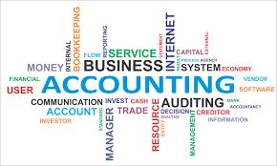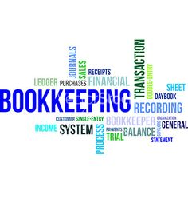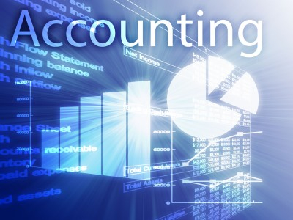

30